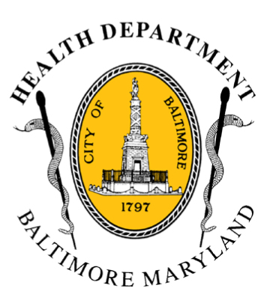
BCHD PRESS RELEASE
Baltimore City Health Department
1001 E. Fayette Street • Baltimore, Maryland 21202
Stephanie Rawlings-Blake, Mayor
Leana Wen, M.D., Commissioner of Health

FOR IMMEDIATE RELEASE

Media Contact: Michael Schwartzberg, PIO
O: (443) 984-2623 C: (443) 462-7939 E: michael.schwartzberg@baltimorecity.gov
Mayor and Health Commissioner to Hold First of Two Community Forums
For Heroin Treatment and Prevention Taskforce
BALTIMORE, MD (April 1, 2015) – This evening, Mayor Stephanie Rawlings-Blake and Baltimore Health Commissioner Dr. Leana Wen will be holding the first community forum for the Heroin Treatment and Prevention Taskforce.
This taskforce was convened last fall by Mayor Rawlings-Blake to address the critical problem of opioid addiction. Its goal was to study the problem of heroin addiction and propose solutions for improving access to effective treatment and neighborhood compatibility.
Tonight’s meeting will be held from 6-7:30pm at the Gaudenzia Treatment Center, 3643 Woodland Avenue and is open to the public. This is the first of two community meetings scheduled to provide updates on the progress of the taskforce.
“Preventing heroin addiction and improving access to treatment are top health priorities for my administration and for our city,” said Mayor Rawlings-Blake. “We can’t do this work in a vacuum. Tonight’s meeting is an opportunity to continue to engage our community in efforts to address addiction, save lives, and strengthen our city.”

In 2014, Baltimore experienced 226 deaths from drug and alcohol overdose between January and September, 143 of which were heroin-related. There were 246 deaths related to drugs and alcohol in Baltimore City in 2013, with 150 of those due to heroin. The taskforce estimates that Baltimore has 19,000 people who have used heroin in the last year.

“It is a terrible tragedy that we have hundreds of people dying from overdose in our city,” said Dr. Wen. “Under the leadership of Mayor Rawlings-Blake, the Baltimore City Health Department is dedicated to reducing overdose deaths and improving access to quality treatment.”
2-2-2

Tonight’s meeting will include community conversation around three issues: preventing fatal heroin overdoses; increasing access to quality treatment; and improving neighborhood compatibility. A second community meeting for neighborhoods in the east and southeast areas of the city will be held later this spring on a date to be determined. Final recommendations will be released by the Mayor and Health Commissioner this summer.

###

